School and College Performance Tables Service
If you would like to see how well St Mary’s is performing in comparison to other schools, then click on the link below and simply follow the instructions. The link allows you to view and download:
- Exam and test results
- Ofsted reports
- Financial information

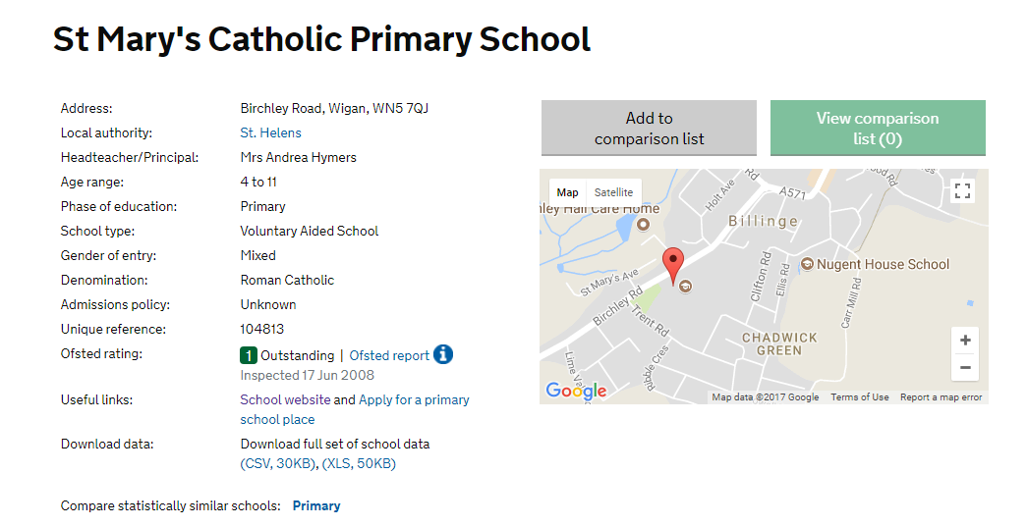

https://www.compare-school-performance.service.gov.uk/school/104813

