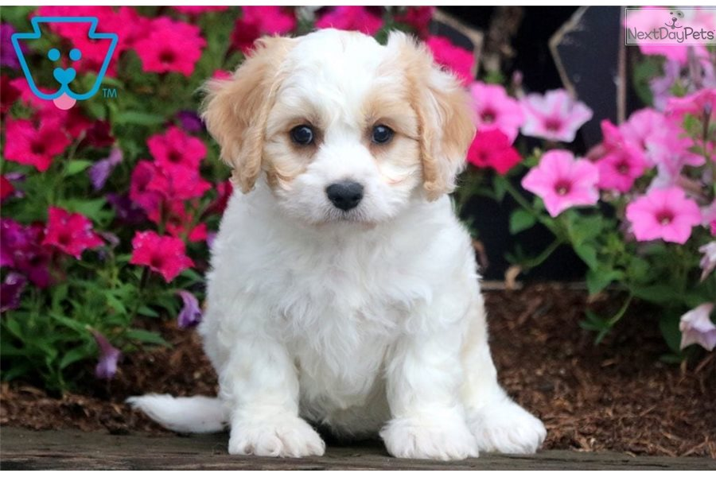

As a vet, you need to show commitment by:

.Decision-making skills. .Interpersonal skills. .Management skills. .Manual dexterity

.Problem-solving skills.

Work hard

Devoted

Dedicated

VETS