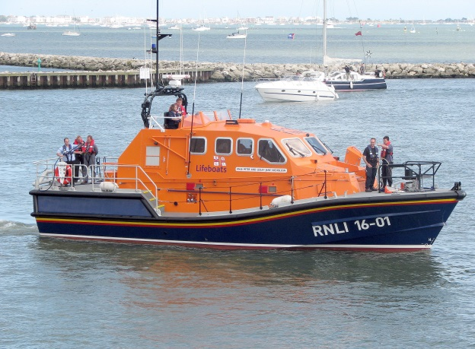

Commitment:
Dedication
Loyal
Don’t give up
Work in hard conditions
Devoted You’d need to show commitment by:
Never giving up on someone stranded
Working whenever someone needs you
Working long, tiring hours
Being dedicated

ROYAL NATIONAL LIFEBOAT INSTITUTION

