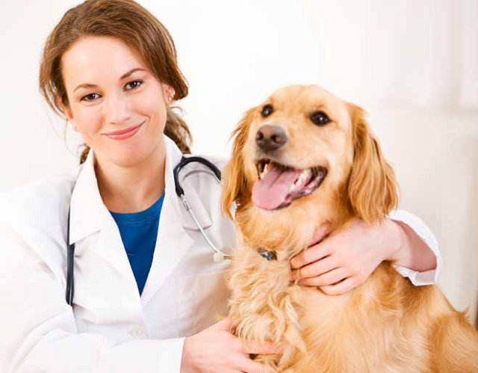
Vet
What does the job Involve
Making sick animals get better, They have to work very hard . Sometimes they have to work at night
Firefighter
They have to put out the fires It is very dangerous . They have to be very brave and they have to work at night

Police-
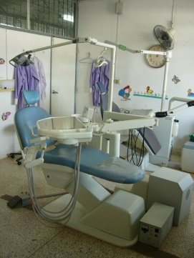
They have to work super hard,catching bad guys and keeping everybody safe.

Dentist-
Has to keep the patients teeth clean and give them flouride

